Name:___________________________ ID:______________________

Programme and class:______________________

Test 30 marks (1 hour 10 minutes)

Mr En Dur, a business owner, provided the following balances that were extracted from his business ledgers as at 31 December 2021.

## Trial Balance as at 31 December 2021

|  |  |  |
| --- | --- | --- |
|  | Debit | Credit |
|  | RM | RM |
| Inventories @ 1 January 2021 | 6,000 |  |
| Sales |  | 90,000 |
| Purchases | 45,000 |  |
| Returns outwards |  | 2,000 |
| Returns inwards | 3,000 |  |
| Wages | 4,000 |  |
| Salaries | 24,000 |  |
| Carriage inwards | 1,200 |  |
| Carriage outwards | 2,400 |  |
| Import tax | 1,300 |  |
| Insurance for purchases | 1,600 |  |
| Other payable |  | 2,200 |
| Rent -600 | 7,800 |  |
| Electricity +50 | 3,600 |  |
| Bad debts + 200 | 100 |  |
| Allowance for doubtful debts @ 1 January 2021 -80 |  | 300 |
| Fixed deposit | 20,000 |  |
| Motor vehicles at cost | 22,500 |  |
| Fixtures at cost | 16,500 |  |
| Equipment at cost | 11,500 |  |
| Accumulated depreciation: Fixtures |  | 2,000 |
| Accumulated depreciation: Equipment |  | 1,080 |
| Drawings +150 | 100 |  |
| Trade receivables -200 | 11,200 |  |
| Trade payables |  | 11,000 |
| Cash -150 | 4,000 |  |
| Bank overdraft |  | 4,400 |
| Capital |  | 72,820 |
|  | 185,800 | 185,800 |

**Additional information:**

1. Closing inventories were valued at cost **RM5,500** but the market value was RM6,900.
2. The business has overpaid on its rental by RM600. This adjustment needs to go to the appropriate accounts. Prepaid rental – 600, CA
3. The staff just discovered that an electricity bill was put in a drawer and not yet paid. This bill was for the month of February 2021, costing RM50. Record this other payable in the appropriate account. Accrual electricity [considered other payables], CL, + 50 in other payables
4. The business had some fixed deposits in its bank account. The bank was giving 5% interest per annum. The business starting depositing this money in **July 2021**, and the interest would only be credited by the end of June each year. The receivables for the year has not been recorded yet.

20,000 * 0.05 = 1000 per year

July 2021 – Dec 2021 = 6/12 * 1000 = 500

Dr Interest receivables 500, CA, Cr Interest received 500, income

1. The owner has used business cash when he had to go to the clinic on an emergency basis. The medical bill cost RM150, which has not been recorded yet.

Drawings + 150, cash - 150

1. A customer, Mr. Barr with an outstanding debt of RM200 is to be written off as bad debts. Allowance for doubtful debts was to be at 2% of trade receivables as at 31 December 2021.

(11,200 – 200) * 0.02 = 220 (latest AFDD)

Decrease in AFDD, 80 (income)

1. Depreciation is to be provided as follows:

Motor vehicles 12% per annum, using the straight line method.

22,500 * 0.12 = 2700

Fixtures All fixtures have a useful life of five years and RM100 scrap value.

(16,500 – 100) / 5 = 3280

Equipment 15% per annum on reducing balance method.

(11,500 – 1080) * 0.15 = 1563

**Required:**

1. Prepare the statement of profit or loss for Mr En Dur for the year ended 31 December 2021.

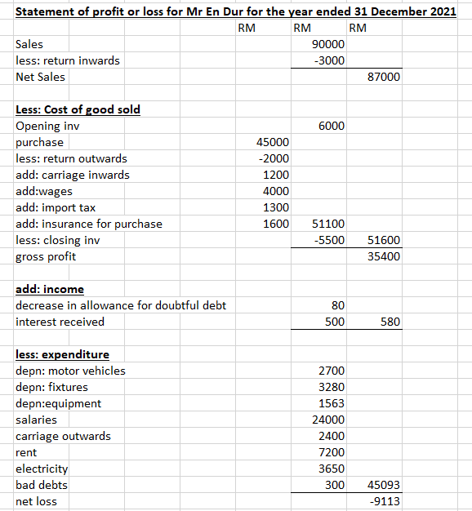

(14 marks)

1. Prepare the statement of financial position as at that date. (13 marks)

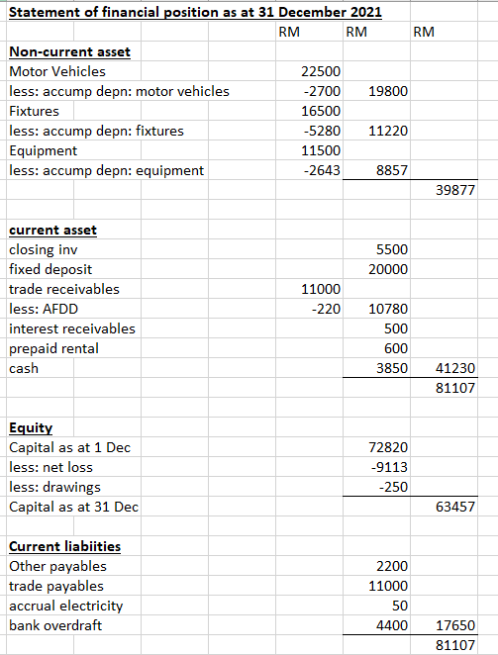

**Question 2**

A business has assets that would wear out over time. There must be a calculation that would give a measurement of the usage of an asset in a given year, i.e. how old has this asset grown or how well-used it is, from the time of purchase to the current time.

**Required:**

(a) State what is this calculation that is able to measure the usage of an asset over time. (1 mark)

depreciation

(b) State **ANY TWO (2)** methods that you know of that could calculate the usage of an asset over time. (2 marks)

Straight-line & reducing-balance (written down value)

[Total: 30 marks]